

✔Internal linking
✔Responsive design
✔Image optimization
✔ Keywords Optimization
✔Headings and content formatting


✔ Link building
✔ Guest posting
✔ Influencer marketing
✔ Social media engagement
✔Content marketing

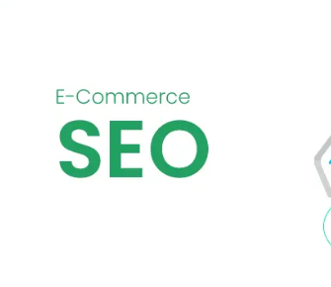
✔ schema markup
✔ Keyword research strategy
✔ Optimize your title tags
✔ Keywords ranking
✔ Product category pages



✔ Local SEO audit
✔ Optimize online directories
✔ Create local content
✔ Inbound links
✔ Optimize URL, title tags, and headers

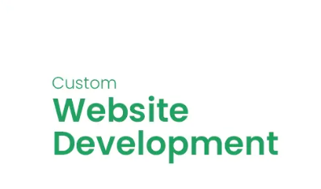
✔ Search engine optimization (SEO)
✔ User experience (UX) design
✔ Back-end development
✔ Responsive web design
✔ Content management

